**Name:** Chillara V L N S Pavana Vamsi

**Reg.no:** 21BCE5095

**Date:** 16/02/2023

**Faculty:** M Sivagami

1. Develop a banker's algorithm for n processes and m resources. Assume that max, allocation and available matrix are given.

* Find the need matrix
* Check the system is in a safe state
* if a request from p1 arrives for (x1,y1,w1,z1), can the requested be granted immediately? will it lead safe state? if it is safe state print the final available matrix .
* if a request from p2 arrives for (x2,y2,w2,z2) can the requested be granted immediately? will it lead safe state? if it is safe state print the final available matrix.

Code:

#include *<stdio.h>*

#define row 5

#define col 4

int compare(int a[col], int b[col])

{

    int x = 0;

    for (int i = 0; i < col; i++)

    {

        if (a[i] <= b[i])

            x++;

    }

    if (x == col)

        return 1;

    else

        return 0;

}

void print_2d(int a[row][col])

{

    for (int i = 0; i < row; i++)

    {

        for (int j = 0; j < col; j++)

            printf(*"%d "*, a[i][j]);

        printf(*"\n"*);

    }

    printf(*"\n"*);

}

int safers(int required[][col], int allocation[][col], int available[col])

{

    int current[col];

    int flag = 0, rc = 0;

    int final[row];

    for (int i = 0; i < row; i++)

        final[i] = 0;

    for (int i = 0; i < col; i++)

        current[i] = available[i];

    for (int i = 0; i < row; i++)

    {

        for (int j = 0; j < row; j++)

        {

            if (final[j] == 0)

            {

                flag=0;

                for (int k = 0; k < col; k++)

                {

                    if (current[k] >= required[j][k])

                        flag++;

                }

                if (flag == col)

                {

                    for (int k = 0; k < col; k++)

                    {

                        current[k] += allocation[j][k];

                    }

                    final[j] = 1;

                    printf(*"P[%d]=>"*, j);

                }

            }

        }

    }

    for (int i = 0; i < row; i++)

    {

        if (final[i] == 1)

            rc++;

    }

    if (rc == row)

    {

        return 0;

    }

    else

        return 1;

}

void process(int *x*, int resources_required[][col], int allocation[row][col], int required[row][col], int available[col], int *k*)

{

    int t;

    int new_allocation[row][col], new_required[row][col], new_available[col];

    for (int i = 0; i < row; i++)

    {

        for (int j = 0; j < col; j++)

        {

            new_allocation[i][j] = allocation[i][j];

            new_required[i][j] = required[i][j];

            new_available[j] = available[j];

        }

    }

    if (compare(resources_required[k], new_available))

    {

        for (int i = 0; i < col; i++)

        {

            t = resources_required[k][i];

            new_allocation[x][i] = new_allocation[x][i] + t;

            new_available[i] = new_available[i] - t;

            new_required[x][i] = new_required[x][i] - t;

        }

        if (safers(new_required, new_allocation, new_available) == 0)

        {

            printf(*"\nProcess %d Request is safe to add.\n"*, x + 1);

            for (int i = 0; i < col; i++)

            {

                t = resources_required[k][i];

                allocation[x][i] = allocation[x][i] + t;

                available[i] = available[i] - t;

                required[x][i] = required[x][i] - t;

            }

        }

        else

            printf(*"\nProcess %d required makes a deadlock.\n"*, x);

    }

    else

        printf(*"\nProcess %d Request cannot be accepted due to less resources available.\n"*, x);

}

void resourcerequired(int allocation[row][col], int required[row][col], int available[col])

{

    int n, x;

    printf(*"No of Request:"*);

    scanf(*"%d"*, &n);

    int process_required[n];

    int resources_required[n][col];

    for (int i = 0; i < n; i++)

    {

        printf(*"Process id:"*);

        scanf(*"%d"*, &process_required[i]);

        printf(*"Request resources:"*);

        for (int j = 0; j < col; j++)

            scanf(*"%d"*, &resources_required[i][j]);

    }

    for (int i = 0; i < n; i++)

    {

        process(process_required[i], resources_required, allocation, required, available, i);

    }

}

void getRequired(int max[][col], int allocation[][col], int required[][col])

{

    for (int i = 0; i < row; i++)

    {

        for (int j = 0; j < col; j++)

        {

            required[i][j] = max[i][j] - allocation[i][j];

        }

    }

}

int main()

{

    printf(*"Row:%d\nColumn:%d\n"*, row, col);

    printf(*"Max Matrix input:\n"*);

    int max[row][col]; *//5 1 1 7 3 2 1 1 3 3 2 1 4 6 1 2 6 3 2 5*

    for (int i = 0; i < row; i++)

    {

        for (int j = 0; j < col; j++)

        {

            scanf(*"%d"*, &max[i][j]);

        }}

    printf(*"Allocation Matrix:\n"*);

    int allocation[row][col];*// 3 0 1 4 2 2 1 0 3 1 2 1 0 5 1 0 4 2 1 2*

    for (int i = 0; i < row; i++)

    {

        for (int j = 0; j < col; j++)

        {

            scanf(*"%d"*, &allocation[i][j]);

        }

    }

    printf(*"Available Matrix:\n"*);

    int available[col];*// 0 3 0 1*

    for (int i = 0; i < col; i++)

        scanf(*"%d"*, &available[i]);

    int required[row][col];

    getRequired(max, allocation, required);

    printf(*"Required Matrix:\n"*);

    print_2d(required);

    int new_allocation[row][col], new_required[row][col], new_available[col];

    for (int i = 0; i < row; i++)

    {

        for (int j = 0; j < col; j++)

        {

            new_allocation[i][j] = allocation[i][j];

            new_required[i][j] = required[i][j];

            new_available[j] = available[j];

        }}

    print_2d(new_required);

        print_2d(new_allocation);

    int res = safers(required, allocation, available);

    if (res == 1)

        printf(*"Gives DeadLock\n\n"*);

    else

        printf(*"Safe\n\n"*);

    resourcerequired(new_allocation, new_required, new_available);

    return 0;

}

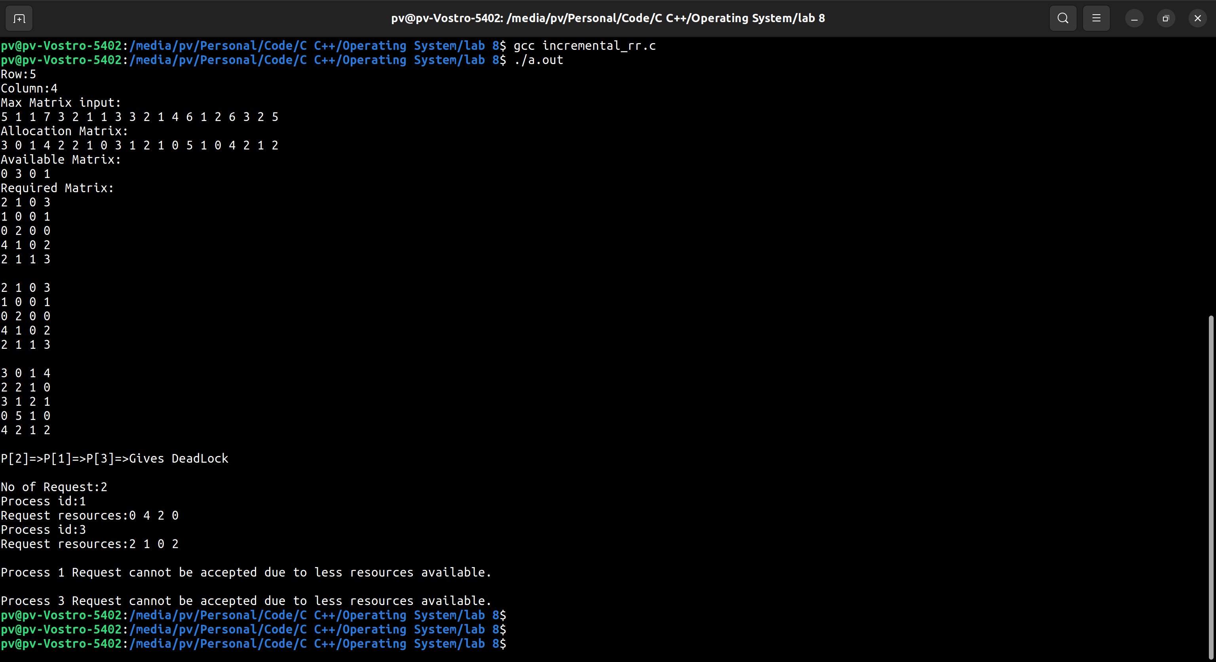 Output:

1. Develop a C program to identify the minimum requirement of each resources of m for n processes.

Code:

#include *<stdio.h>*

int main()

{

    int i, j, count = 0, tot = 0, row = 3, col = 3;

    int request[row][col];*//3 4 5 4 5 6 5 6 7*

    printf(*"Need Matrix:\n"*);

    for (int i = 0; i < row; i++)

    {

        for (int j = 0; j < col; j++)

        {

                scanf(*"%d"*,&request[i][j]);

        }

    }

    for (i = 0; i < col; i++)

    {

        count = 0;

        tot = 0;

        for (j = 0; j < row; j++)

        {

            count += request[j][i] - 1;

        }

        tot += count + 1;

        printf(*"Minimum requirement of resouce R%d is %d\n"*, i, tot);

    }

    return 0;

}

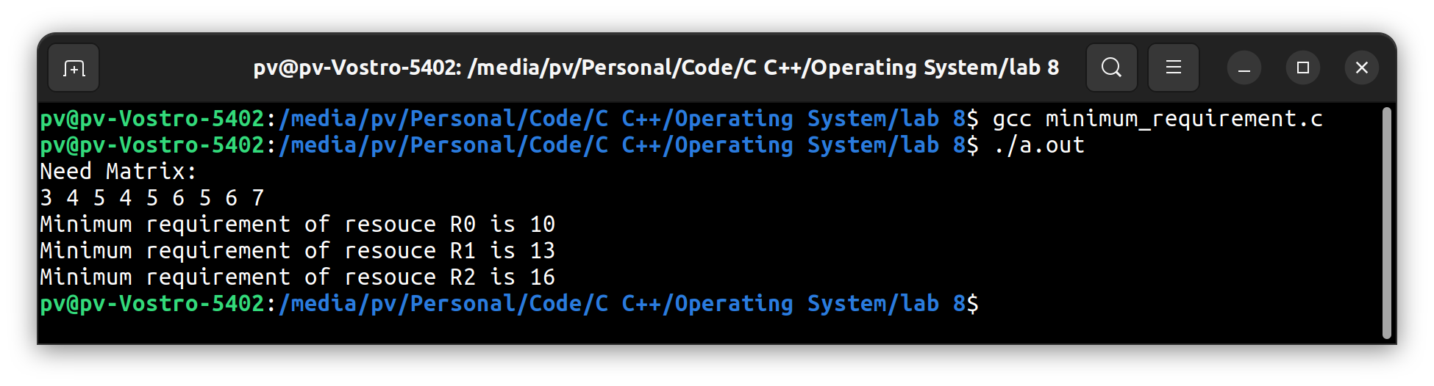Output:

1. Develop a c program as a multilevel feedback scheduler and show the output for the below scenario for n process with different arrival times and different burst for 3 level of schedulers

Note: Level1 - 8-time units level 2 - 16 time units and level3 – FCFS

Code:

#include *<stdio.h>*

struct process

{

    char name;

    int AT, BT, WT, TAT, RT, CT;

} Q1[10], Q2[10], Q3[10];

int n;

void sortByArrival()

{

    struct process temp;

    int i, j;

    for (i = 0; i < n; i++)

    {

        for (j = i + 1; j < n; j++)

        {

            if (Q1[i].AT > Q1[j].AT)

            {

                temp = Q1[i];

                Q1[i] = Q1[j];

                Q1[j] = temp;

            }

        }

    }

}

int main()

{

    int i, j, k = 0, r = 0, time = 0, tq1 = 8, tq2 = 16, flag = 0,count=0;

    char c;

    printf(*"Enter no of processes:"*);

    scanf(*"%d"*, &n);

    for (i = 0, c = *'A'*; i < n; i++, c++)

    {

        Q1[i].name = c;

        printf(*"\nEnter the arrival time and burst time of process %c: "*, Q1[i].name);

        scanf(*"%d%d"*, &Q1[i].AT, &Q1[i].BT);

        Q1[i].RT = Q1[i].BT;

    }

    sortByArrival();

    time = Q1[0].AT;

    printf(*"Process in first queue following RR with qt=%d"*, tq1);

    printf(*"\nProcess\t\tRT\t\tWT\t\tTAT\t\t"*);

    for (i = 0; i < n; i++)

    {

        if (Q1[i].RT <= tq1)

        {

            time += Q1[i].RT;

            Q1[i].RT = 0;

            Q1[i].WT = time - Q1[i].AT - Q1[i].BT;

            Q1[i].TAT = time - Q1[i].AT;

            printf(*"\n%c\t\t%d\t\t%d\t\t%d"*, Q1[i].name, Q1[i].BT, Q1[i].WT, Q1[i].TAT);

        }

        else

        {

            Q2[k].WT = time;

            time += tq1;

            Q1[i].RT -= tq1;

            Q2[k].BT = Q1[i].RT;

            Q2[k].RT = Q2[k].BT;

            Q2[k].name = Q1[i].name;

            k = k + 1;

            flag = 1;

            count++;

        }

    }

    if(count==n)

    printf(*"\nNo Process ends in queue 1"*);

    if (flag == 1)

    {

        printf(*"\n\nProcess in second queue following RR with qt=%d"*, tq2);

        printf(*"\nProcess\t\tRT\t\tWT\t\tTAT\t\t"*);

    }

    for (i = 0; i < k; i++)

    {

        if (Q2[i].RT <= tq2)

        {

            time += Q2[i].RT;

            Q2[i].RT = 0;

            Q2[i].WT = time - tq1 - Q2[i].BT;

            Q2[i].TAT = time - Q2[i].AT;

            printf(*"\n%c\t\t%d\t\t%d\t\t%d"*, Q2[i].name, Q2[i].BT, Q2[i].WT, Q2[i].TAT);

        }

        else

        {

            Q3[r].AT = time;

            time += tq2;

            Q2[i].RT -= tq2;

            Q3[r].BT = Q2[i].RT;

            Q3[r].RT = Q3[r].BT;

            Q3[r].name = Q2[i].name;

            r = r + 1;

            flag = 2;

        }

    }

    {

        if (flag == 2)

            printf(*"\n\nProcess in third queue following FCFS "*);

    }

    for (i = 0; i < r; i++)

    {

        if (i == 0)

            Q3[i].CT = Q3[i].BT + time - tq1 - tq2;

        else

            Q3[i].CT = Q3[i - 1].CT + Q3[i].BT;

    }

    for (i = 0; i < r; i++)

    {

        Q3[i].TAT = Q3[i].CT;

        Q3[i].WT = Q3[i].TAT - Q3[i].BT;

        printf(*"\n%c\t\t%d\t\t%d\t\t%d\t\t"*, Q3[i].name, Q3[i].BT, Q3[i].WT, Q3[i].TAT);

    }

    printf(*"\n"*);

    return 0;

}

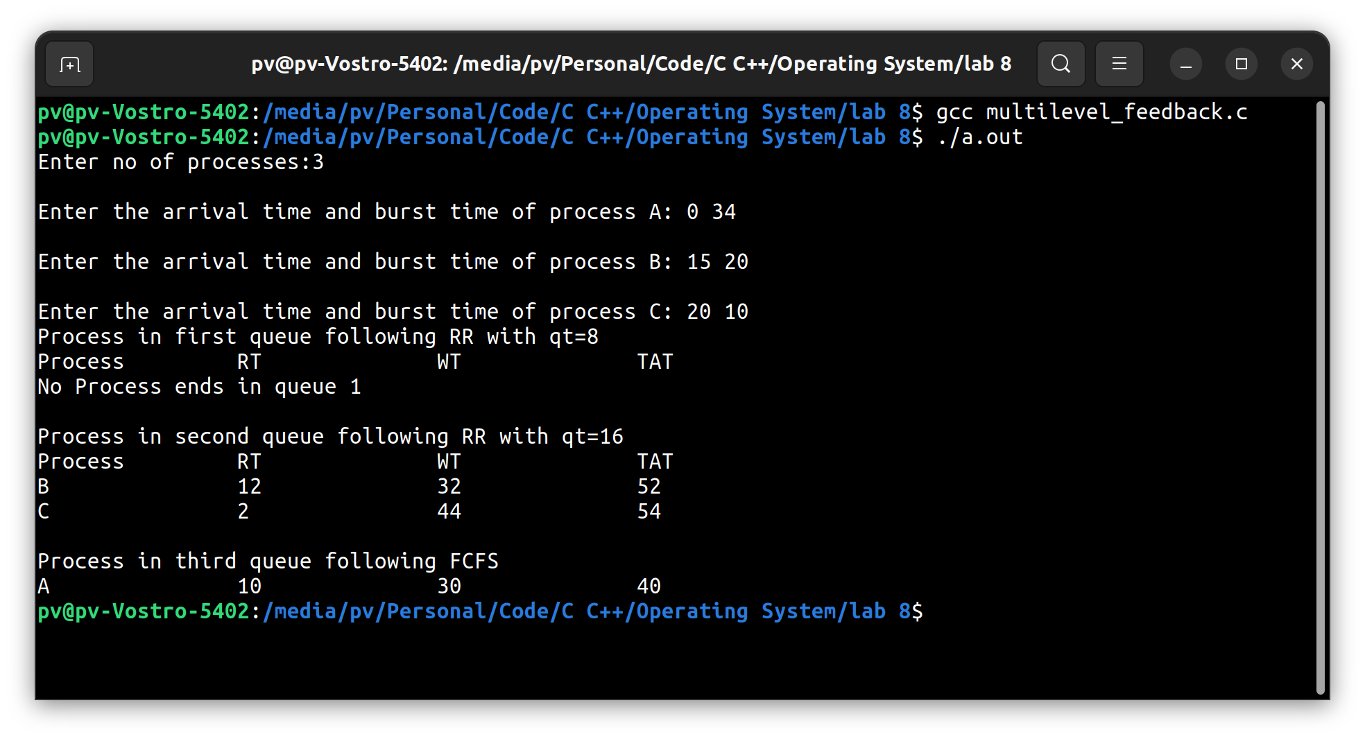Output: